# SUMMER INTERNSHIP MINI PROJECT

TELECOM COUSTOMER CHURN PREDECTION

TEAM MEMBERS: M. Sriram

: D. Padmaksh

: S. Sushanth

: M. Manoj

: K. Gaurav

**Telecom customer churn prediction**

**INTRODUCTION:**

The telecommunications sector has become one of the main industries in developed countries. The technical progress and the increasing number of operators raised the level of competition

Companies are working hard to survive in this competitive market depending on multiple strategies. Three main strategies have been proposed to generate more revenues:

(1) Acquire new customers,

(2) Up sell the existing customers, and

(3) Increase the retention period of customers.

However, comparing these strategies taking the value of return on investment of each into account has shown that the third strategy is the most profitable strategy, proves that retaining an existing customer costs much lower than acquiring a new one , in addition to being considered much easier than the up selling strategy . To apply the third strategy, companies have to decrease the potential of customer’s churn, known as “the customer movement from one provider to another”.

Customers’ churn is a considerable concern in service sectors with high competitive services. On the other hand, predicting the customers who are likely to leave the company will represent potentially large additional revenue source if it is done in the early phase



**OBJECTIVES OF THE STUDY:**

The main objective of the study is to evaluate customers’ satisfaction or dissatisfaction of cell phone companies **SPECIFIC OBJECTIVES**

1. To know the most affective factors on service quality, service features, customers’ satisfaction, customers’ loyalty and recommendation.

2. To know which customers are more satisfied of their networks?

3. To know which company’s customers are more satisfied?

4. To know which factor is most important from service quality and service features.

5. To know which mobile service is widely used by the customers.

6. To know about the customers who are moving from one service to another.

**PROBLEM STATEMENT:**

The problem statement describes the content for the study and it also identifies the general analysis approach. Day-by-day, competition has been increased more and more in telecommunication market. Cell Phone Service Providers must compete in order to remain profitable. Today, with the increasing recognition of the importance of customer retention and loyalty, companies now understand the importance of service. The idea is that to understand the needs of customers as well as the changes in their needs over the time would allow Cell Phone Service Providers to become more customer focused and hence remain profitable over the time. To know about the loyal customers we have used churn prediction to identify the loyal customers over a certain period of time.

**REVIEW OF LITERATURE:**

• ***CHURN PREDICTION***:

Prediction of customers who are in the stage to leave the company is called as churn prediction .The company should take necessary steps to retain them .This issue is very important one because retaining the customers is less expensive than acquiring a new one.

• ***Fraud Detection***:

Fraud is very expensive activity in the telecom sector .so the telecom companies should try to find the fraudulent users and partners.

**DATA COLLECTION**

* Dataset is collected from kaggle.com which are having various datasets of them our dataset is Telecom customer churn prediction. our dataset include various independent an dependent variables of them some are
  + - * + Tenure
        + Partner
        + Dependents
        + Online backup
        + Online security
        + Churn

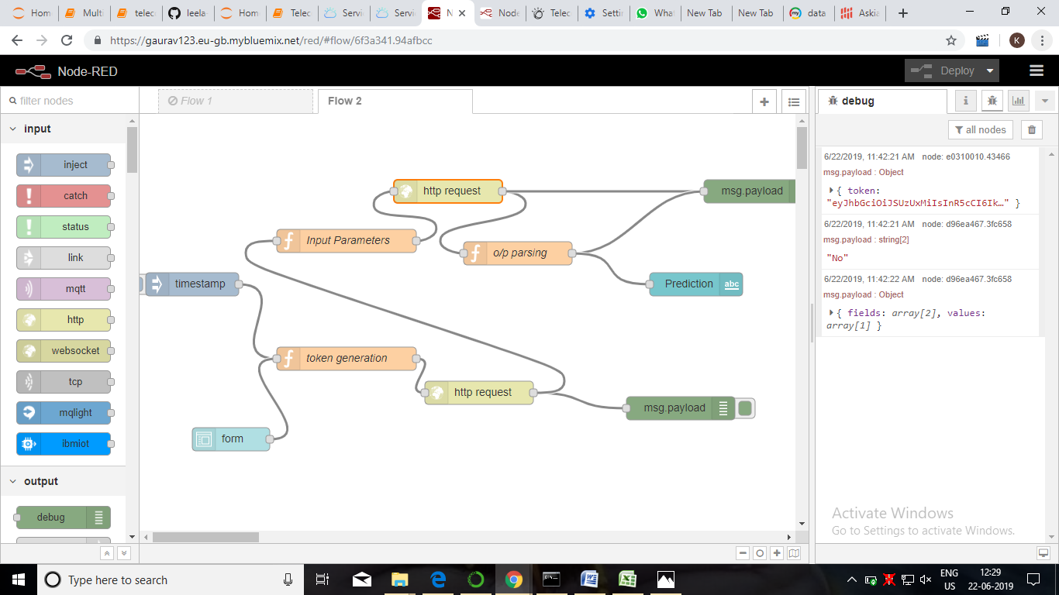

**METHODOLOGY**

* Kraggle dataset is obtained from the wireless network community
* The dataset consists of 7000 customers information
* The amount of churn customer is 17.3%
* More information can be found on kraggle dataset

4.1 exploratory data analysis

Churn prediction of input parameters

* Converts structured and unstructured data/information into meaningful insights
* Utilizes these insights to predict customers who are likely to churn
* Identifies the causes for churn and works to resolve those issues
* Engages with customers to foster relationships
* Implements effective programs for customer retention

4.1.1 figures and tables

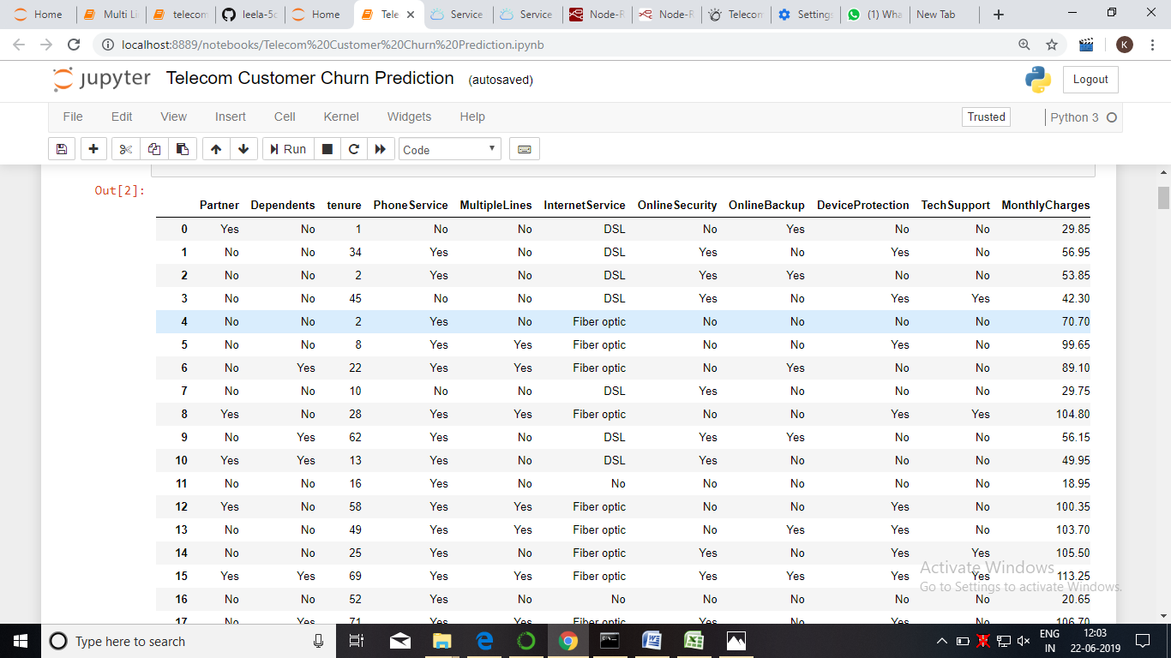

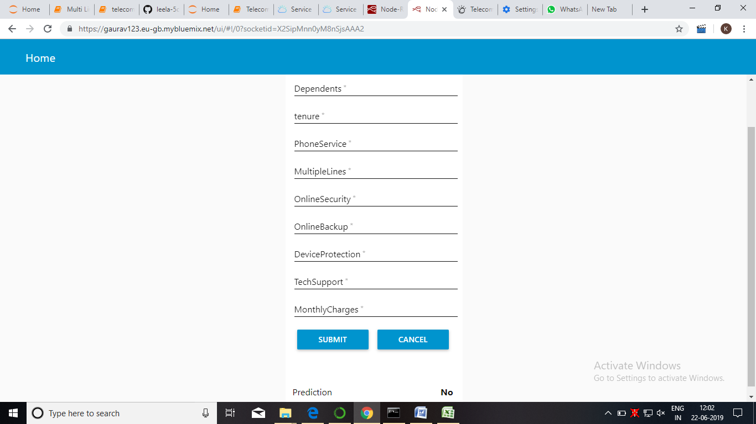

4.2 statistical technique and data visuvalization

We have used node red model to predict the customers churn movement from one service to another depending on their partner ,tenure ,online ,tech support ,montlycharges and according to this the churn prediction and the classifiers used in this desicion tree ,random forest ,KNN classifiers

The final output of the churn prediction is dependent of variables input.

4.3 data modelling using supervised ml techniques

* We have used ml techniques like classification algorithms
* Classification algorithms include decision tree and random forest and knn classifiers

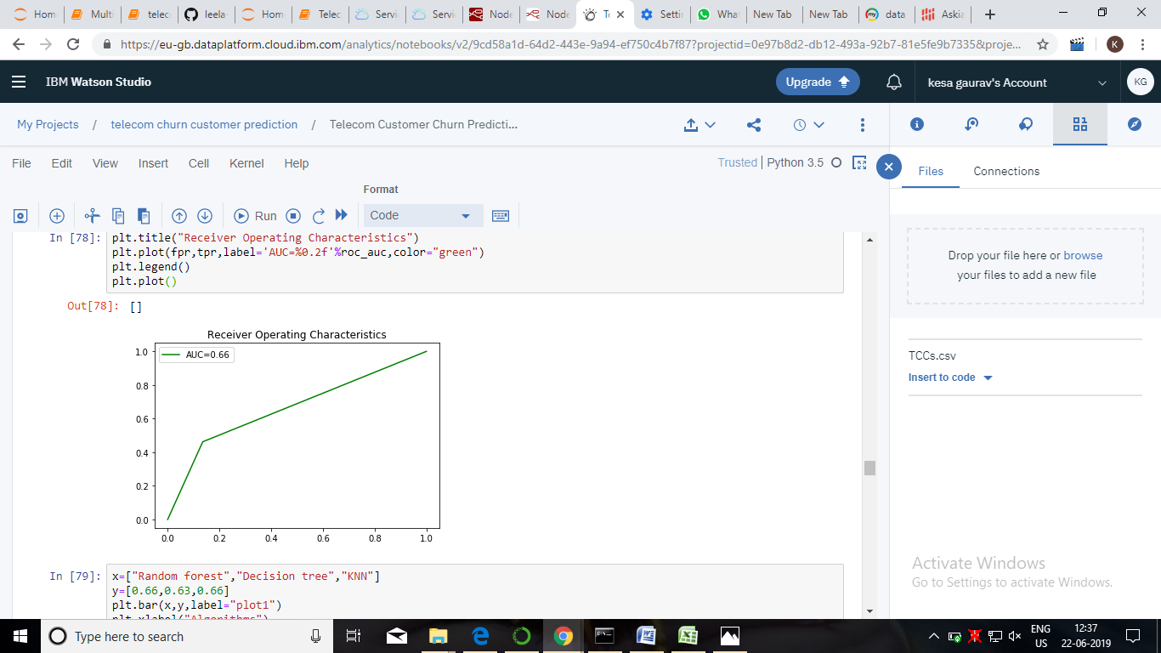

Findings and suggestions

* Referred from kraggle site which consists of large sets of data science include projects i.e telecom churn customer prediction
* Referred from other sites from research gate for data collection of churn prediction of loyal and non-loyal customers

**CONCLUSION**

Today telecommunication industry is facing a critical issue of customer churn. Ultimately revenue loss is the cause of issue. The only way to avoid revenue loss which happens due to churn,was the prediction of customer churn. Machine Learning techniques like decision tree and multiple regression are used to predict the telecom customers so that the retention activity can be taken against them.